Feedbacks:

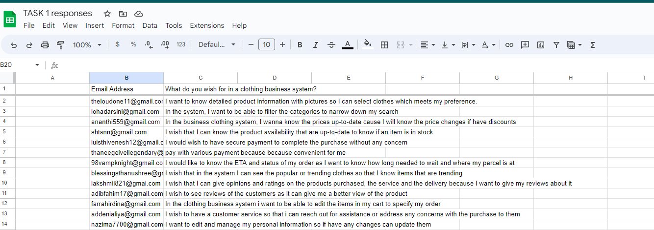

User Story:

1. As a user, I want to know detailed product information, including pictures, so that I can select clothing items that meet my preferences
2. As a user, I want filter clothing categories, allowing me to easily narrow down my search.
3. As a user, I want to know prices that are up-to-date so that if there are any discounts, I will know of the price changes it.
4. As a user, I want to know the up-to-date product availability so I can know if a specific item is in stock.
5. As a user, I want to have secure payment so that I can complete the purchase without any concerns.
6. As a user, I want to be able to pay with various payments so that it is convenient for me
7. As a user I want to know the estimated time of arrival and status of my order so that I know how long to wait and where my parcel at.
8. As a user, I want to know to be able to view popular or trending clothing so I can know the trending items
9. As a user I want to able to write my opinion and give ratings on the products purchased including their service and delivery to give my reviews on them.
10. As a user, I want to be able to view reviews of other customers to give me a better view of the product.
11. As a user, I want to be able to edit items in my cart to specify my order
12. As a user, I want to have customer service system, so that I can simply reach out for assistance or address any concerns with my purchase.
13. As a user, I want to be to be able to edit and manage my personal information so I can update them if there are any changes.

User Story Mapping

<https://www.figma.com/file/jq7c0wztgxmBP7WmXqlBhS/Clothing-Business-System?type=whiteboard&node-id=0-1&t=2xG5j7b2RXv2YAwb-0>



